 | Vehicle Reservation System  Technical Design Document  1.0
 | Prepared By / Last Updated By | Reviewed By | Approved By
Name | Samreeti Sharma  Vaibhav Gramni  Shehryar Ahmed Khan  Shivam Manchanda  Yashkumar Saini | Person 2 | Person 3
Role | Team Member | Team Member | Scrum Master
Signature
Date

Table of Contents

1.0 Introduction 3
1.1 Purpose of this document 3
1.2 Scope 3
1.3 Intended Audience 3
1.4 Definition & Acronyms 3
2.0 Conventions and Standards Followed 4
3.0 Assumptions, Dependencies and Risks 4
3.1 Assumptions: 4
3.2 Dependencies: 4
4.0 Schematic Diagram 4
5.0 Use Case Realization 5
5.1.1 User Registration 5
a. Functional Requirement 6
b. UI Validations 6
c. UI Controls 7
d. UI Methods Definition 8
e. UI Design 9
6.0 Database Design 10
6.1 Tables Structure 10
7.0 Change Log 13

Introduction

Purpose of this document
The purpose of the detail design document is to define the detailed design for all the components of Vehicle Reservation system that are specified in the Business Requirement/Use case document. All the low level components, interfaces and integrations are detailed out in this document.

Scope
This sub-section shall state the scope of this detailed design document
• Create and maintain user information.
• Create and maintain Vehicle information

Intended Audience
The intended audience for this document are
- Developers, testers, other associates in the project
- Technical lead, Scrum Master
- Product Owner

Conventions and Standards Followed
The modules under scope needs to adhere to the coding standards and guidelines

Assumptions, Dependencies and Risks

Assumptions:
- Once the application is built the VEHICLE RESERVATION SYSTEM MONITOR PORTAL will manually load the user list into the system.
- There will be no concurrent users for the application. The Users profile will be maintained by the Admin.
- Any changes to the design mentioned in the BRD would be taken as a Change Request

Dependencies:
- Availability of database design characteristics & access shall be defined by the
- Resource availability throughout each of the sprint

Schematic Diagram
A schematic, or schematic diagram, is a representation of the elements of a system using abstract, graphic symbols rather than realistic pictures. It gives an overview of overall system
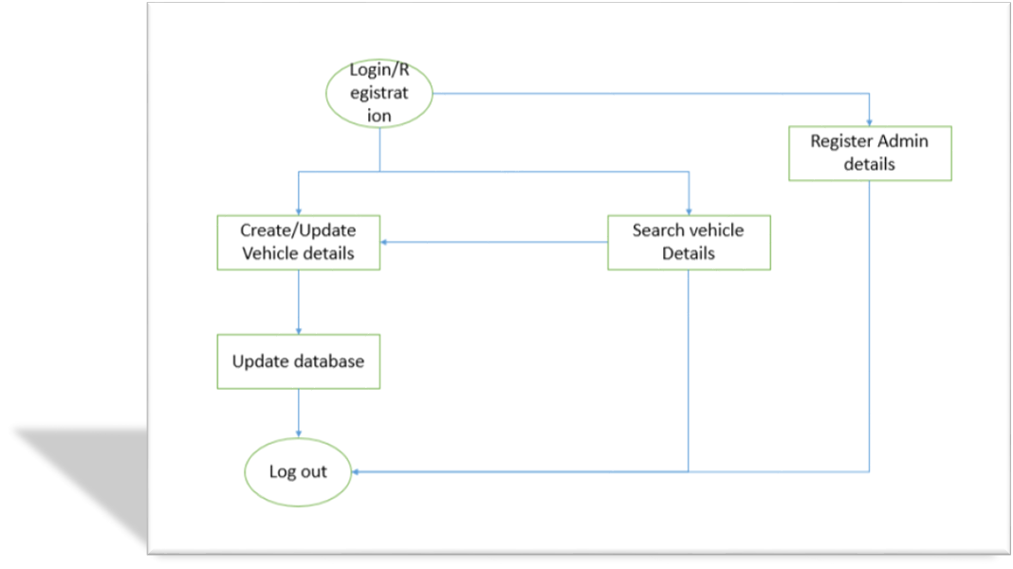
The above pic is only an example and not representational of the Vehicle Reservation System project

Use Case Realization

User Registration

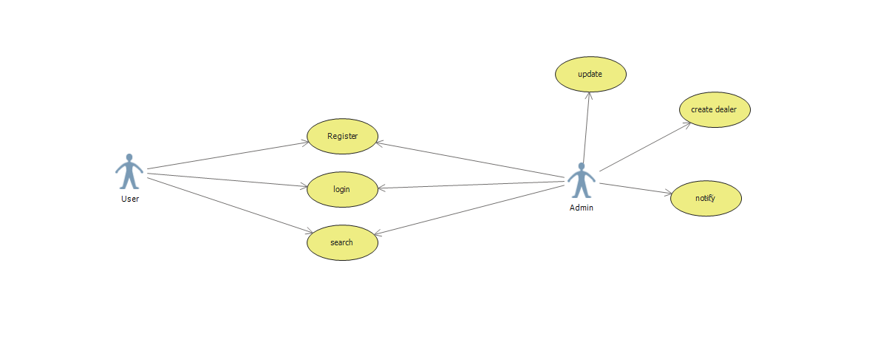

Functional Requirement
. Login Page checks the authentication of the user and based on his role, directs the user to the respective page. User will provided with Add User Details, Login and Search Vehicle details.

UI Validations
- UserName and Password fields are mandatory.
- Invalid User Id and / or password should not allow the user to get into the system

UI Controls
# | UI Component | Type | Name | Details
1 | UserName | Label | label_For_User_Name
2 | User | Text field | Textfield_user | To enter username
3 | password | Label | Label_for_password
4 | password | Text field | Textfield_password | To enter password

UI Methods Definition
Method Name | Parameter | Details
Userinfo() | none | Allows the user to Insert user details
Vehicle_info() | none | Allows to enter vehicle details
LoginUser() | None | Allows the user to login after registering their details.
Admin_Login() | none | Allows the admin to login.
UpdateVehicle() | none | Allows the admin to update vehicle details.
Update_User() | none | Allows the admin to update the user details.
vehicleSearch() | none | Allows the admin/user to search vehicle details.

UI Design


Database Design

Tables Structure
UserInfo:
Column Name | Data Type | Length | Nulls
Employee Id | varchar | 6 | N
First Name | varchar | 50 | N
Last Name | varchar | 50 | N
Age | numeric | 2 | N
Gender | NA | - | N
Contact Number | varchar | 10 | N
Email | varchar | 50 | N
Password | varchar | 15 | N
Branch | varchar | 5 | N
Role | varchar | 5 | N

VehicleInfo:
Column Name | Data Type | Length | Nulls
Vehicle No | varchar | 10 | N
Branch | varchar | 10 | N
Vehicle type | varchar | 10 | N
Insurance Expiry date | date | 10 | N
Last Serviced Date | date | 10 | N
Service Due date | Date | 10 | N

Change Log
Please note that this table needs to be maintained even if a Configuration Management tool is used.
Version Number | Changes made
V1.0 | <First version>
V1.1 | <If the change details are not explicitly documented in the table below, reference should be provided here>
V1.1 | Page no | Changed by | Effective date | Changes effected
V1.2 | <If the change details are not explicitly documented in the table below, reference should be provided here>
V1.2 | Page no | Changed by | Effective date | Changes effected

